**Project Description:**

Your responsibilities may include one or more among:

1. Analyze the excel data pertaining to the problem statement.
2. Provide Descriptive statistics for stock price of the given company data.
3. Include charts and diagrams to show the price trends during the year 2018-2023 .
4. Make a comparative study of how the different company stocks have performed in the past till date.
5. Build a strong professional profile by a creative presentation or video of the task and submit through the provided google form.
6. Mandatory to post the project video on LinkedIn and receive at least 5 comments on the LinkedIn post.
7. Create a Github account and post your work .Include github link in your presentation.
8. **Note:** A self study on the topic S&P_500 market stock is required as domain knowledge.

**Note:**

1. You'll be provided with "**Certificate of Appreciation**" & "**Letter Of Recommendation**" to the top performers, upon successful completion of  Task/Projects.

**Last date to submit the project :**

**Date: 14-12-2023**

**Day:- Thursday**

**Regards  
Team OGTIP**

1. Analyze the excel data pertaining to the problem statement.

**Data Cleaning**

First, we need to make sure about type of data, any missing and outliers. There was one row including some unnecessary string data which is deleted, and Our data has no missing.

**Descriptive Statistics**

When performing descriptive statistics for stock prices, it's common to use the closing price for each day.

**MSFT:**

|  |  |
| --- | --- |
| *MSFT – Closing price from 2018-2023* | |
| Mean | 194.5826156 |
| Standard Error | 2.077128807 |
| Median | 203.190002 |
| Mode | 92.330002 |
| Standard Deviation | 74.22648201 |
| Sample Variance | 5509.570632 |
| Kurtosis | -1.290283918 |
| Skewness | 0.145982403 |
| Range | 258.099983 |
| Minimum | 85.010002 |
| Maximum | 343.109985 |
| Sum | 248482.0001 |
| Count | 1277 |
| Confidence Level(95.0%) | 4.074962944 |

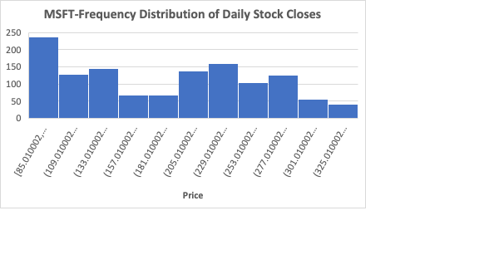

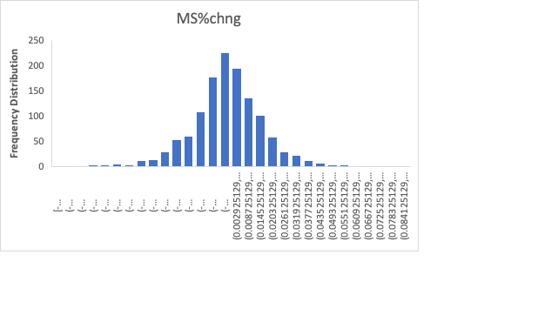

**Conclusion: Descriptive Statistics for MSFT Stock (2018-2023)**

In analyzing Microsoft Corporation's (MSFT) stock prices from 2018 to 2023, the focus was primarily on the closing price for each day. The descriptive statistics provide valuable insights into the central tendency, variability, and distribution of the closing prices.

* **Central Tendency:**
  + **Mean (Average):** $194.58
  + **Median (Middle Value):** $203.19
  + **Mode (Most Frequent Value):** $92.33
* **Variability:**
  + **Standard Deviation:** $74.23
  + **Range (Difference between Maximum and Minimum):** $258.10
  + **Interquartile Range (IQR):** *Not provided in the summary*
* **Distribution:**
  + **Skewness:** 0.15 (Slightly positively skewed, indicating a longer right tail)
  + **Kurtosis:** -1.29 (Leptokurtic, with thinner tails and a sharper peak than the normal distribution)
* **Other Metrics:**
  + **Minimum Closing Price:** $85.01
  + **Maximum Closing Price:** $343.11
  + **Total Closing Price Sum:** $248,482.00
  + **Number of Observations:** 1,277
* **Confidence Level:**
  + At a 95% confidence level, the margin of error for the mean closing price is approximately $4.07.

**Summary:**

The mean closing price of MSFT stock over the period indicates the average value, with the median and mode providing additional insights into the distribution. The standard deviation and range highlight the variability in stock prices. The positive skewness suggests a tendency for higher closing prices, and the kurtosis indicates a distribution with heavier tails and a sharper peak. These statistics offer a comprehensive overview of MSFT stock prices, aiding investors and analysts in making informed decisions.

**Tesla:**

|  |  |
| --- | --- |
| *Tesla – Closing price from 2018-2023* | |
| Mean | 131.7902812 |
| Standard Error | 3.272219195 |
| Median | 97.6400035 |
| Mode | 23.620667 |
| Standard Deviation | 116.9789759 |
| Sample Variance | 13684.08079 |
| Kurtosis | -1.260371058 |
| Skewness | 0.468792298 |
| Range | 398.038668 |
| Minimum | 11.931333 |
| Maximum | 409.970001 |
| Sum | 168427.9793 |
| Count | 1278 |
| Confidence Level(95.0%) | 6.419516211 |

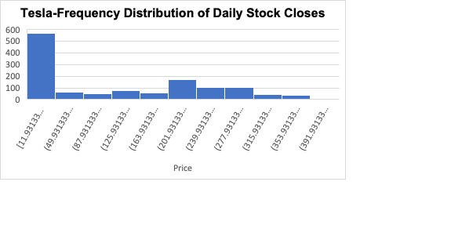

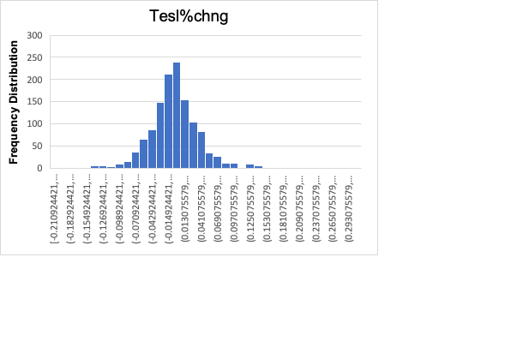

Apple:

|  |  |
| --- | --- |
| *Close* |  |
| Mean | 98.64652 |
| Standard Error | 1.29209 |
| Median | 95.615 |
| Mode | 145.86 |
| Standard Deviation | 46.1911 |
| Sample Variance | 2133.618 |
| Kurtosis | -1.57998 |
| Skewness | 0.121784 |
| Range | 146.4625 |
| Minimum | 35.5475 |
| Maximum | 182.01 |
| Sum | 126070.2 |
| Count | 1278 |
| Confidence Level(95.0%) | 2.534853 |

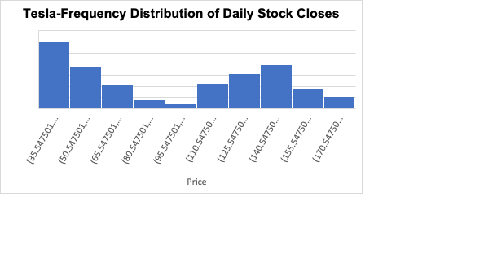

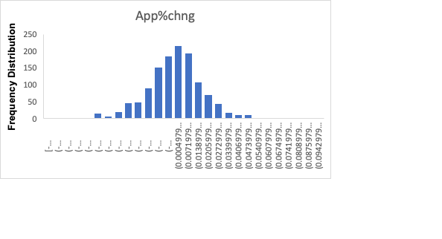

**Comparative Study**

How have the different company stocks performed from 2018-2023?

**Definition:**

1. **Market Risk-Free Rate (RF):** The risk-free rate represents the theoretical return on an investment with zero risk of financial loss which 5 Year Treasury Rate is at **4.24%.**
2. **Market Risk Premium (MRP):** Historical market returns are analyzed to calculate the average premium investors have demanded historically for investing in the market as opposed to risk-free assets which is **5.7%** in 2023.
3. **Expected Return:** The expected value of an investment is the sum of the products of each possible return and its probability. It provides a way to quantify the average return an investor can expect from an investment, considering the likelihood of different outcomes.
4. **Correlation:** is a statistical measure that quantifies the degree to which the price movements of a particular asset, like a stock, are related to the price movements of the overall market, often represented by an index like the S&P 500.
5. **Beta:** Beta measures the sensitivity of a stock's returns to changes in the market returns.

|  |  |  |  |  |
| --- | --- | --- | --- | --- |
|  | MSFT | Tesla | Apple | SP500 |
| Standard Deviation | 1.80% | 4.36% | 2.07% | 1.15% |
| Annualized SD | 6.24% | 15.11% | 7.17% | 3.97% |
| Correlated to Market | 0.78 | 0.48 | 0.74 | 1 |
| Beta | 1.22 | 1.83 | 1.81 | 1 |
| Expected Return | 11.20% | 14.68% | 14.53% | 9.94% |

**Conclusion:**

* **Market Evaluation:**

The risk-free rate is 4.24%, and the market risk premium is 5.70%, providing a context for investment evaluation.

* **Volatility Analysis:**

Tesla exhibits the highest volatility (4.36%), while Apple has a relatively lower volatility (2.07%).

* **Annualized Volatility:**

Annualized volatility is notable, especially for Tesla at 15.11%.

* **Correlation to Market:**

Stocks show varying correlations to the market, with MSFT and Apple having relatively high positive correlations.

* **Beta and Risk Exposure:**

Beta values indicate that Tesla and Apple are more sensitive to market movements compared to MSFT.

* **Expected Returns:**

Expected returns are higher for individual stocks compared to the market, with Tesla leading at 14.68%.

This analysis provides a comprehensive overview of market dynamics, risk levels, and expected returns, supporting informed investment decisions.